F74046129 資訊一乙 孫譽 project2:工具人達人

UML class diagram:

|  |
| --- |
| MainWindow |
| -mainwindow  -Dialog *mdialog  -Dialog2 *edialog  -QMediaPlayer *cena  -QMediaPlayer *nice |
| + MainWindow  -on_pushButton_clicked():void  -on_exitButtion_clicked():void  -on_startButton_clicked():void |

MainWindow主要為視窗UI間的切換

以及背景音樂的撥放等等

|  |
| --- |
| Taiko |
| + Taiko(QWidget * parent= 0)  +QGraphicsScene * scene  +QGraphicsView * view  +HitArea * hitarea |
| +timeleft():void  -private slots: showtime():void |

Taiko 主要為遊戲畫面場景的設立還有

放置打擊區(感應鼓的地方)

|  |
| --- |
| HitArea |
| + int score = 0  -QMediaPlayer * leftdrum  -QMediaPlayer * rightdrum |
| +HitArea(QGraphicsItem * parent = 0)  +keyPressEvent(QKeyEvent * event) : void  +slots:  Spawn():void  Turnback():void |

HitArea包含對鼓面的感應區hitarea還有

當按下J K鍵時不同的反應

另外還有隨機鼓面的生成

|  |
| --- |
| Drum1 |
|  |
| +Drum1(QGraphicsItem * parent =0)  +slots  Move():void |

Drum1 簡單設定第一種鼓(騎車載他)的移動方式及限制

|  |
| --- |
| Drum2 |
|  |
| +Drum2(QGraphicsItem * parent =0)  +slots  Move():void |

Drum2 簡單設定第二種鼓(買消夜)的移動方式及限制

|  |
| --- |
| Dialog |
| -Ui::Dialog *ui |
| +explicit Dialog(QWidget *parent = 0)  -slot  On_pushButton_clicked:void |

Dialog 包含了從menu到how to play的ui切換

|  |
| --- |
| Dialog2 |
| -Ui::Dialog2 *ui |
| +explicit Dialog2(QWidget *parent = 0)  -slot  On_pushButton_clicked:void |

Dialog2 包含了結算畫面到menu的ui切換

Project截圖:

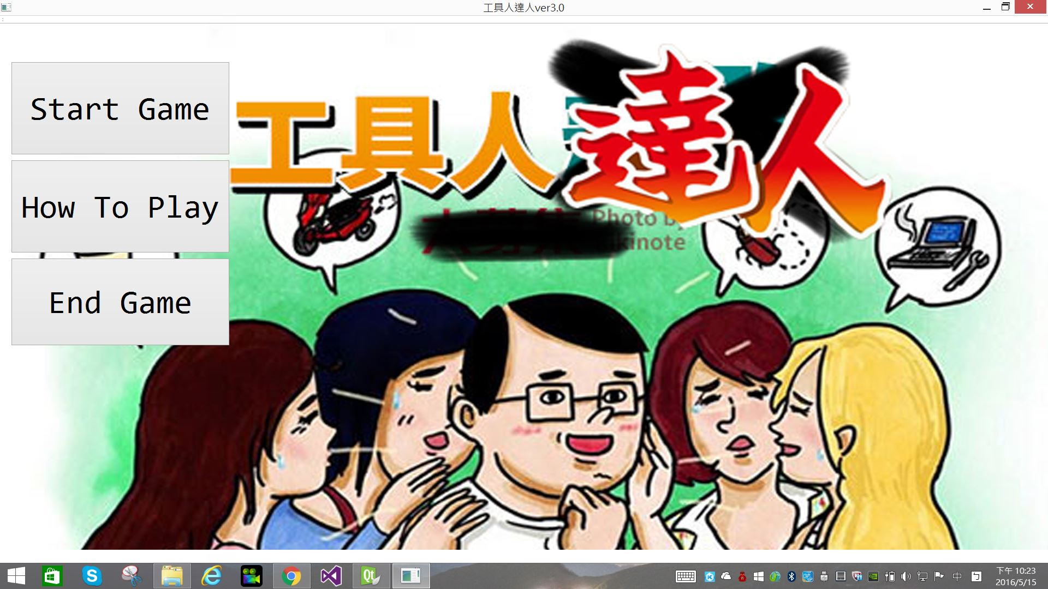

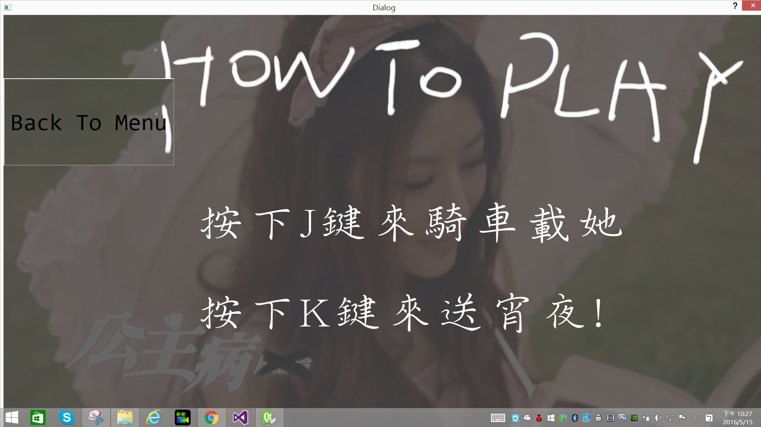

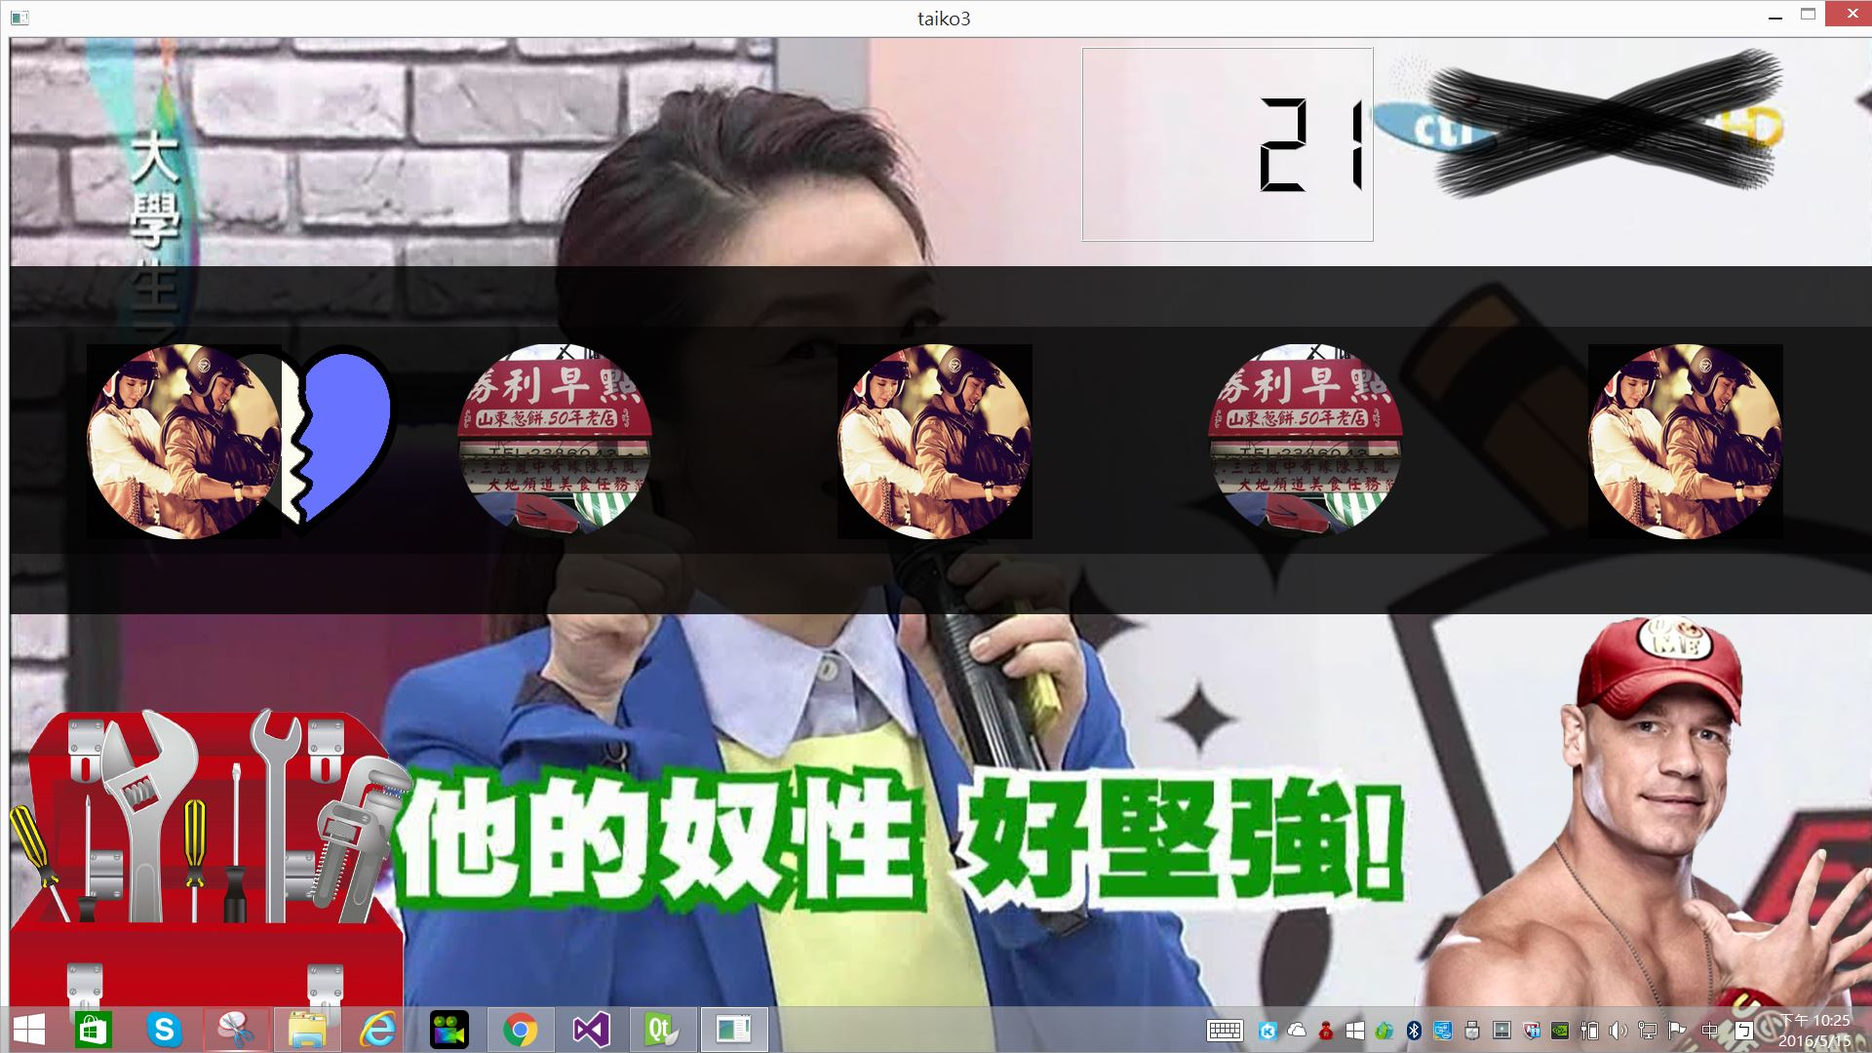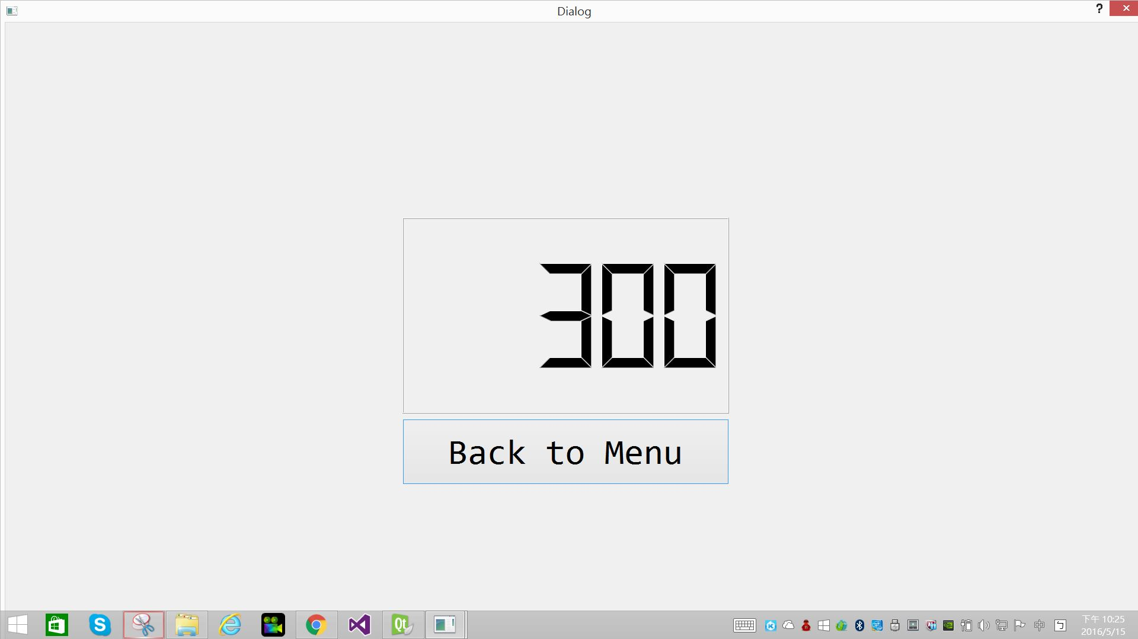

遊戲畫面 按下J 愛心變成左邊紅色 加上鼓聲

按下K 愛心變成右邊藍色 加上鼓聲

右上角有LcdNumber倒數秒數